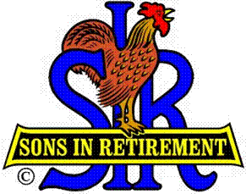

Las Trampas Branch 116

Luncheon Meeting Agenda

November 19, 2018

11:30 AM
- Call to Order – Big Sir.
- Welcome: Big SIR Marty Katz
- Pledge of Allegiance: Big SIR Marty Katz
- Invocation Big SIR Marty Katz
- Story Teller: Big SIR Marty Katz
- Introduce Head Table:
- Little Sir: Jerry Hicks
- Guest Speaker – Little SIR Guest Introduction, Colonel Chris Starling, United States Marines, Retired
- Introduce Guests & Visitors
- Guests: George Mitchell, Bill Duncan
- New Member: Dan Lawrence – (Sponsor Don Benioff)
- Past Big SIRS – Please Stand to be recognized
- Vistors:
- Recognize Certificate Achiever Awards: Bill Hayes 35 years
- Certificate of Appreciation: Kevin Donahue, Harry Sherinian, Al Hutchko
- Induction of New Branch Executive Committee and Directors
- Committee Reports

- 11:45 PM – Lunch
- Raffle Drawing
- Sunshine Report

- 12:30 PM HONOR OUR VETERANS AND THOSE THAT SUPPORT OUR VETERANS VIDEO Thank you Neil Schmidt

- Little SIR Introduce Speaker

- November Birthdays

- TERM ENDING CLOSING REMARKS FROM BIG SIR

- Sing God Bless America

- AJORN

